
Lab 2
Name: M.Salman
Roll No:2504480
Submitted To: Sir Mohabbat Ali

Task 1
Create Personal web Page
Home page
<!DOCTYPE html>
<html lang="en">
<head>
<meta charset="UTF-8">
<title>Home</title>
<link rel="stylesheet" href="style.css">
</head>
<body>
<nav>
<a href="index.html">Home</a>
<a href="about.html">About</a>
<a href="services.html">Services</a>
<a href="contact.html">Contact</a>
</nav>
<section class="hero">
<img src="https://share.google/grzjvIryF4gHNzHcC" alt="Profile Picture">
<h1>I'm Designer</h1>
<h2>Rao Salman</h2>
<p>Professional web designer creating modern websites.</p>
</section>
</body>
</html>
About Page
<!DOCTYPE html>
<html>
<head>
<title>About Me</title>
<link rel="stylesheet" href="style.css">
</head>
<body>
<nav>
<a href="index.html">Home</a>
<a href="about.html">About</a>
<a href="services.html">Services</a>
<a href="contact.html">Contact</a>
</nav>
<h1>About Me</h1>
<p>
My name is Salman. I am a web designer and developer.
I create responsive and modern websites.
</p>
</body>
</html>
Services Page
<html>
<head>
<title>Se<!DOCTYPE html>
rvices</title>
<link rel="stylesheet" href="style.css">
</head>
<body>
<nav>
<a href="index.html">Home</a>
<a href="about.html">About</a>
<a href="services.html">Services</a>
<a href="contact.html">Contact</a>
</nav>
<h1>My Services</h1>
<ul>
<li>Web Design</li>
<li>HTML & CSS</li>
<li>Responsive Websites</li>
</ul>

</body>
</html>
Contact Page
<!DOCTYPE html>
<html>
<head>
<title>Contact</title>
<link rel="stylesheet" href="style.css">
</head>
<body>
<nav>
<a href="index.html">Home</a>
<a href="about.html">About</a>
<a href="services.html">Services</a>
<a href="contact.html">Contact</a>
</nav>
<h1>Contact Me</h1>
<p>Email: example@gmail.com</p>
<p>Phone: 0319*****</p>
</body>
</html>

Style.css
body {
font-family: Arial;
margin: 0;
background-color: #686e79;
}
nav {
background: #222;
padding: 15px;
text-align: center;
}
nav a {
color: white;
margin: 0 15px;
text-decoration: none;
font-weight: bold;
}
nav a:hover {
color: #ff4b2b;
}
.hero {
text-align: center;
padding: 50px;
}
.hero img {
width: 200px;
border-radius: 50%;
margin-bottom: 20px;
}
h1 {
color: #ff4b2b;
}

Screenshot
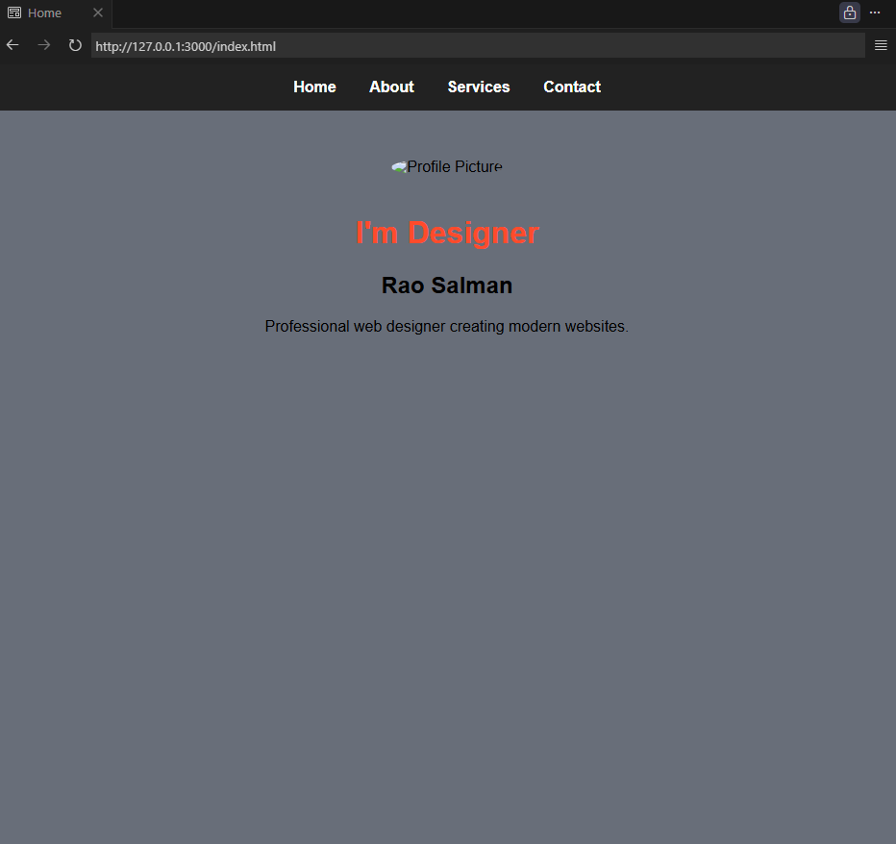
About page
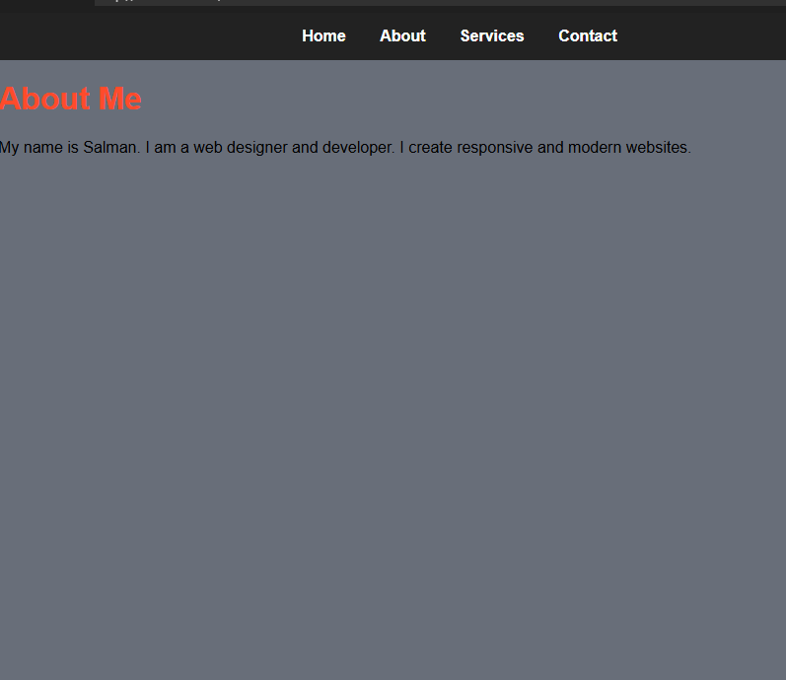

Task 2
Create Product Page
Product Page
<!DOCTYPE html>
<html lang="en">
<head>
<meta charset="UTF-8">
<title>Product Page</title>
<link rel="stylesheet" href="style.css">
</head>
<body>
<div class="product-card">
<img src="C:\Users\2504480\Pictures\s10-pro-smart-watch-series-10-pakistan-priceoye-df0av-270x270.webp" alt="Product Image">
<h1>Smart Watch</h1>
<p class="description">
This smart watch comes with modern design, heart rate monitor,
long battery life and water resistance. Perfect for daily use.
</p>
<p class="price">Price: Rs. 4,999</p>
<a href="buy.html" class="buy-btn">Buy Now</a>
</div>
</body>
</html>

Buy Now Page
<!DOCTYPE html>
<html>
<head>
<title>Buy Now</title>
<link rel="stylesheet" href="style.css">
</head>
<body>
<div class="product-card">
<h1>Order Confirmed</h1>
<p>Thank you for buying our product 😊</p>
<p>We will contact you soon.</p>
<a href="product.html" class="buy-btn">Go Back</a>
</div>
</body>
</html>
Style.Css
body {
margin: 0;
padding: 0;
font-family: Arial, sans-serif;
background-color: #f2f4f8;
}
.product-card {
width: 350px;
background: white;
margin: 80px auto;
padding: 20px;
text-align: center;
border-radius: 10px;
box-shadow: 0 10px 25px rgba(0,0,0,0.1);
}
.product-card img {
width: 100%;
border-radius: 10px;
}
.product-card h1 {
margin: 15px 0;
color: #222;
}
.description {
font-size: 14px;
color: #555;
margin: 15px 0;
}
.price {
font-size: 20px;
font-weight: bold;
color: #ff4b2b;
margin: 15px 0;
}
.buy-btn {
padding: 12px 30px;
font-size: 16px;
border: none;
background-color: #ff4b2b;
color: white;
border-radius: 5px;
cursor: pointer;
transition: 0.3s;
}
.buy-btn:hover {
background-color: #222;
transform: scale(1.05);
}
Screenshot
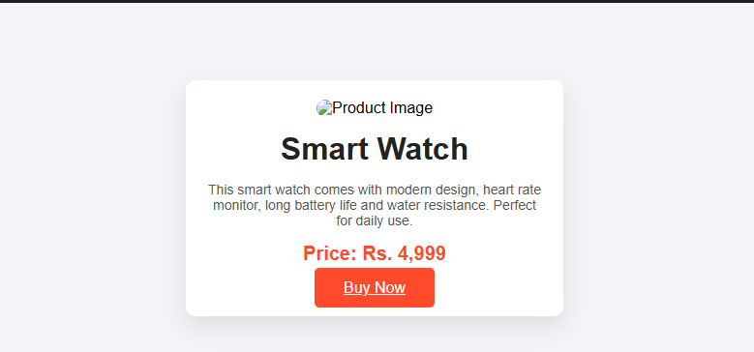

Buy Now Page
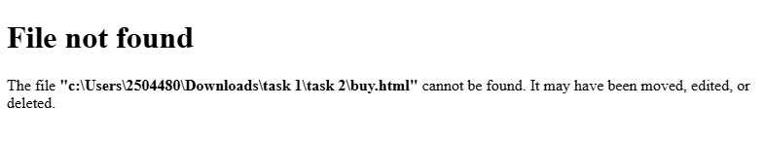

Task 3
Create a Login Form Page
Dashboard
<!DOCTYPE html>
<html lang="en">
<head>
<meta charset="UTF-8">
<title>Dashboard</title>
<link rel="stylesheet" href="style.css">
</head>
<body class="login-body">
<div class="login-box">
<h1>Welcome 🎉</h1>
<p>You have successfully logged in.</p>
<a href="login.html" class="logout-btn">Logout</a>
</div>
</body>
</html>
Login Page
<!DOCTYPE html>
<html lang="en">
<head>
<meta charset="UTF-8">
<title>Login</title>
<link rel="stylesheet" href="style.css">
</head>
<body class="login-body">
<div class="login-box">
<h2>Login</h2>
<form action="dashboard.html">
<input type="text" placeholder="Username" required>
<input type="password" placeholder="Password" required>
<button type="submit">Login</button>
</form>

<p class="link-text">
New user?
<a href="signup.html">Create account</a>
</p>
</div>
</body>
</html>

Signup
<!DOCTYPE html>
<html lang="en">
<head>
<meta charset="UTF-8">
<title>Sign Up</title>
<link rel="stylesheet" href="style.css">
</head>
<body class="login-body">
<div class="login-box">
<h2>Create Account</h2>
<form action="dashboard.html">
<input type="text" placeholder="Full Name" required>
<input type="email" placeholder="Email" required>
<input type="text" placeholder="Username" required>
<input type="password" placeholder="Password" required>
<button type="submit">Sign Up</button>
</form>
<p class="link-text">
Already have an account?
<a href="login.html">Login</a>
</p>
</div>
</body>
</html>

Style.css
.login-body {
margin: 0;
height: 100vh;
background: linear-gradient(135deg, #667eea, #764ba2);
display: flex;
justify-content: center;
align-items: center;
font-family: Arial, sans-serif;
}

/* Box */
.login-box {
background: white;
padding: 40px;
width: 320px;
text-align: center;
border-radius: 12px;
box-shadow: 0 15px 30px rgba(0,0,0,0.2);
}

/* Headings */
.login-box h2,
.login-box h1 {
margin-bottom: 25px;
color: #333;
}
.login-box input {
width: 100%;
padding: 12px;
margin: 10px 0;
border-radius: 25px;
border: 1px solid #ccc;
outline: none;
}
.login-box button {
width: 100%;
padding: 12px;
background: #667eea;
border: none;
color: white;
font-size: 16px;
border-radius: 25px;
cursor: pointer;
transition: 0.3s;
}
.login-box button:hover {
background: #764ba2;
}
.link-text {
margin-top: 15px;
font-size: 14px;
}

.link-text a {
color: #667eea;
text-decoration: none;
font-weight: bold;
}

.link-text a:hover {
text-decoration: underline;
}
.logout-btn {
display: inline-block;
margin-top: 20px;
padding: 10px 25px;
background: #ff4b2b;
color: white;
text-decoration: none;
border-radius: 25px;
}
.logout-btn:hover {
background: #222;
}
Screen shot
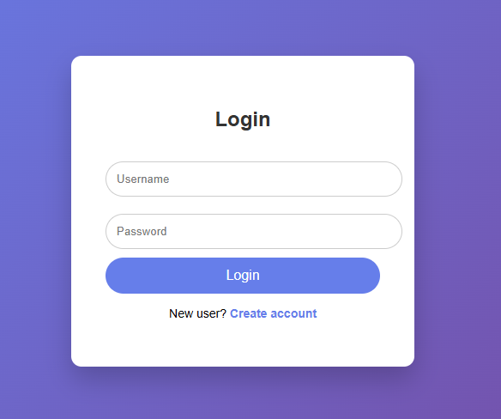
Create new accout
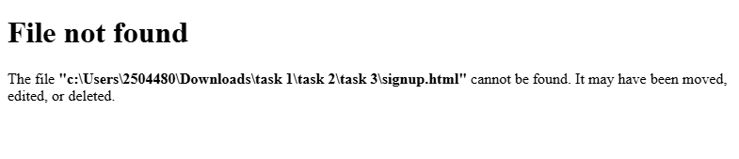
Login page
